

Happen Business Pty Limited
ABN 78 097 893 573
www.happen.biz
Jim2 Business Engine V2.10 release notes – 28/05/2003

Official Release - Build 1311

V2.10 marks a significant milestone for our product, Jim2 Business Engine. New features allow use in Retail and Distribution environments as well as the traditional Sales, Service and Manufacturing that we have handled up to date. The inclusion of Event and Menu scripting allows increased flexibility and customisation and enabling us to further tune the product to the clients ever changing requirements.

One significant new feature is the long awaited GST sessions and full support for both Cash and Accrual reporting methods. We believe we handle the complexities of the GST better than any other package on the market - one of the benefits of using Australian developed software.

Additional enhancements to the User Interface, Workflow and Business System integration have quickly established Jim2 BE as THE business software in the Australian IT and many other industries.

Our new slogan, “Seriously Powerful Business Software Made Easy”, sums up exactly what Happen aim to achieve. Powerful, Australian business tools that are extremely useable in day to day business, that can grow and adapt to clients ever-changing needs.

Some of the more exciting new features include…

- NEW - Auto Pick Job List
Also…
Further additions to Stock Attributes.
Further enhancements to Debtor Statements
Additional Search fields in Quote List
Unprinting Invoices allows Payments to be reversed
Stock Form enhancements
Job List Enhancements
Debtor refunds From Unbanked Funds

Plus changes to:
SECURITY
REPORTS /GLOBAL VARIABLES
FIXES & IMPROVEMENTS

And here’s some Print and Distribute “cheat sheets” to add to your collections:

GST SESSIONS
RETAIL
- NEW - Create Purchase Orders directly from Job or Job List
- NEW - All Lists now save there Grouping/Order/Layout etc
- NEW - New Retail mode
- NEW - Receipt Printing reports
- NEW - Cash Draw control
- NEW - Till reconciliation
- NEW - Cash Rounding
- NEW - Invoicing authentication security
- NEW - RTV when PO is on received
- NEW - New Stock On Hand/ Committed/ Available information.
- NEW - Quick Login mode
- NEW - Event Scripts
- NEW - Menu Scripts
- NEW - Negative Banking (cash returns etc)
- NEW - ‘From’ supported on Purchase Orders
- NEW - Stock Select by location (on the fly)
- NEW - Shortcuts keys
- NEW - Auto BCC email
- NEW - GST Sessions
- NEW - Support of the Cash GST method

Make sure you read up on these changes to OPTIONS – there may be one or many you can use to enhance Jim2 even further:
NEW Options – General
NEW Options – Jobs
NEW Options – Stock
NEW Options – Purchases
NEW Options – Accounting
NEW Options – Retail

Technical Information & Requirements

Database V118

To upgrade from Jim2 V2.0 to Jim2 V2.10 backup your database then run the jim2upgrade_210_build_1311.exe upgrade program on your server.

The Jim2 update program will automatically update existing databases to the current version 118. That is – by running the Version 2.10 upgrade, you will have access to these new features and functions WITHOUT affecting your existing Jim2 records.

To manually update a database you have restored:

1. Use the Jim Update program and run the Jim2update117-118pas script.
2. New reports, scripts etc can installed by importing the jim2reports_v210.jrpt file via the Jim2 Report Designer.

Both these files can be located in the UpdateFiles subdirectory after running the jim2upgrade_210_build_1311.exe upgrade program.

Jim2Server V1.9
Minor updates to handle Till reconciliation and GST sessions.

Important Notice - Microsoft SQL Service Packs
Prior to upgrading to Jim2 Business Engine Version 2.10, you must ensure you have the latest Microsoft SQL Service Packs installed, with respect to your current network requirements. Check with your Network Administrator prior to actioning.

If you are currently running Microsoft SQL 7 or MSDE (supplied with Jim2 Business Engine for sites up to 5 users) you should download Microsoft SQL7 Service Pack 4.
This service pack is recommended.

Click Here to download Microsoft SQL 7 Service Pack 4 (42Mb approx)
OR

If you are currently running Microsoft MSDE 2000 you should download Microsoft MSDE 2000 Service Pack 3a.
This service pack is recommended.

Click Here to download Microsoft MSDE 2000 Service Pack 3a (70Mb approx)
OR

If you are currently running Microsoft SQL 2000 you should download Microsoft SQL2000 Service Pack 3a.
This service pack is recommended.

Click Here to download Microsoft SQL 2000 Service Pack 3a (50Mb approx)

Why?
Microsoft SQL Server 7 Service Pack fixes all known SQL issues and allows use of passwords on the SA account. Jim2 BE uses mixed mode security. There is a known security issue when running SQL with SA and no password.
Happen recommend that this Service pack be installed, however it is not required.

Microsoft SQL Server 2000 appears to have a data integrity issue that is resolved by installing the Service Pack 2 (or greater). In the interest of maintaining the integrity of your database Happen insists that this Service Pack be installed.

Click Here for more information on Microsoft SQL 2000 Service Pack 3a

Please contact Happen if you require a consultant to install this for you at your premises

Note: The above Microsoft SQL Server information applies from Jim2 BE v2.09 onwards.
If running Microsoft SQL server 2000 it is recommended that you upgrade to SQL service pack 3a due to a potential security issue that has been resolved by Microsoft.

New – Auto Pick Stock  return to menu

A new Auto Pick Stock feature has been added to Job Lists. The “Auto Pick” function queries any List of Jobs and indicates (as a percentage) the availability of the Stock for each Job in the List.

This is great for Distribution and Sales orientated sites where there would be a large number of active Sales Jobs entered by Sales staff, and the “pick and pack” responsibility is passed to warehouse staff. By creating a List of all Sales Jobs (by any selection criteria), you simply right click within the List result and choose “Auto Pick Stock”. This will open a new “Availability” column in the List, and calculate the percentage of stock available against each Job.

You can also set a “Live List” to Auto Pick by checking the Auto Pick Stock checkbox at the bottom of the List screen and running your live List. On the timed refreshing of that List, the Auto Pick function will recalculate the availability of stock for the Jobs in the List. This process happens in the background and you are free to continue using JIM2 BE in other areas whilst this is happening. As Stock is “received” on Purchase orders, the refresh of your List will take this into consideration.

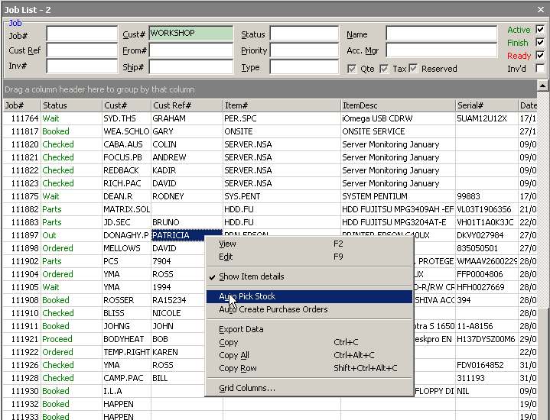

The Availability % score is calculated from the currently available Stock and allocates stock in FIFO (First In - First Out) based the order of the Job List and takes into account the stock requirements of previous Jobs in the list.

HINT: A score of 100% against any Sales Job would obviously indicate it is OK to pick & invoice a Job. However, with respect to backordering “unavailable” Stock, it would be wise to create some general rules for warehouse staff – example: “if stock availability score is 80% or greater, pick & invoice.”

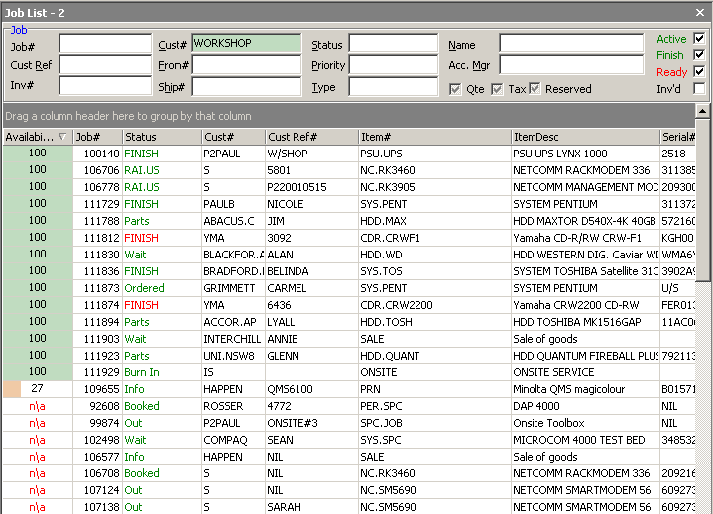

The default rules when backordering Jobs are set in Options>Jobs>Stock Grid Defaults – eg: Supply Only Available (Backorder the rest). By setting these defaults to suit your supply model, in conjunction with this new Auto Pick Stock function, AND the new Auto Create Purchase Order feature, JIM2 BE provides a powerful, efficient and accurate “live” Distribution tool.

New - Auto Create Purchase Orders  return to menu

Yes, it’s here! If you are leaning toward “Just In Time” (JIT) Stock Control, check this new feature out. Now you can easily Auto Create Purchase Orders directly from a Job (or List of Jobs) by right clicking and selecting ‘Auto Create Purchase Orders’.

- You will add the Stock Codes to your Jobs “up-front” (the Job information will update the Purchase Order)
- You then open “a” Job or create a List of Jobs (using any of your List criteria and run the List)
- You right click in the stock grid of “a” Job or anywhere within the Job List result to open the new Auto Create Purchase Order form
- Click RUN to load the stock required from the Job or Job List.
- Make any alterations to the Selected Stock. You are able to over-ride the “Order Qty” column to bring in more stock, and/or change “Vendor” and so on. You can pick and choose which products to order using the “Order” column (check/ uncheck the tick box at a line level or use Select All/Deselect All).
- Press Order, then voila! You have just created Purchase Orders for exactly what you need. You can even EDIT the purchase orders themselves prior to sending them off to your vendors!

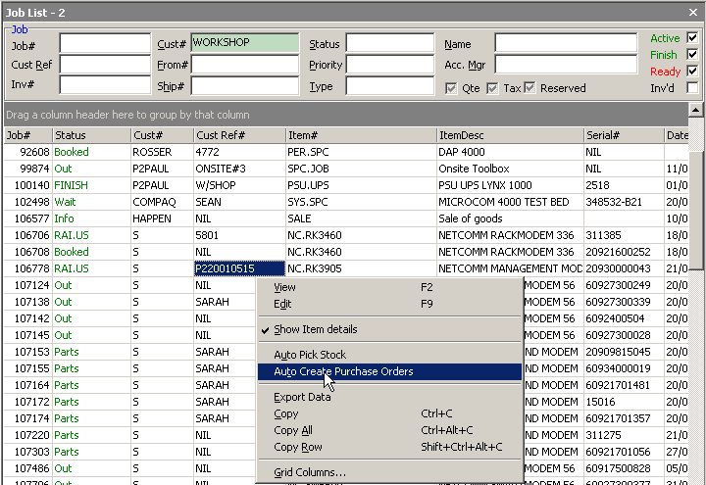

This new feature uses many existing JIM2 BE rules with respect to Stock records to take a whole lot of “guess work” out of Purchasing. In essence, the Auto Create Purchase Order will run through your choice of Jobs and calculate:
- Exactly how many need to be ordered of each Stock (Qty On Hand – Qty On Jobs + Qty On Order already)
- Of what needs to be ordered, which Vendors to raise the PO’s to.

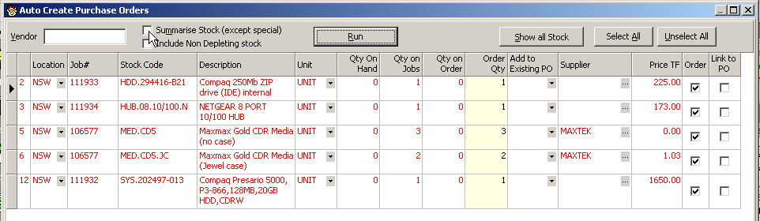

The Auto Create Purchase Order Form allows the following criteria to be selected in any combination:
- Enter a VENDOR code in the form only if you want to create a Purchase Order to one specific Vendor (just for the stock they typically supply you). If you do not enter a Vendor code, JIM2 BE will create multiple Purchase Orders to multiple vendors to fulfil the whole stock requirement. This function is based on the Vendor Ranking for each Stock Code. You can select a different vendor against a stock.
- Tick ‘Summarise Stock’ (default from Job List) if you do not wish to link Purchase Orders directly to the related Job. If you do not tick the Summarise Stock checkbox, JIM2 BE will automatically “link” (allocate) stock, line by line, on the Purchase Orders to their respective Jobs.
- Tick the “Include Non Depleting Stock” if you would like the form to pick up non depleting stock codes. Note here: As non depleting stock quantities are not tracked in JIM2 BE, it cannot calculate how many you need (on hand versus supplied). The “Order Qty” will always equal the total count for that stock as per Qty Ordered on each Job.
- You can display all stock (depleting and non-deleting) from the Job List (Requiring ordering or not) by clicking ‘Show all Stock’. This may help you decide on whether to “top up” certain stock lines before they run out.

Click ORDER and let JIM2 BE generate PO’s to match your criteria choices. Once the PO’ are created, a pop up message will give you the List of PO’s that were just created – now you can edit/send these to your vendors ASAP.

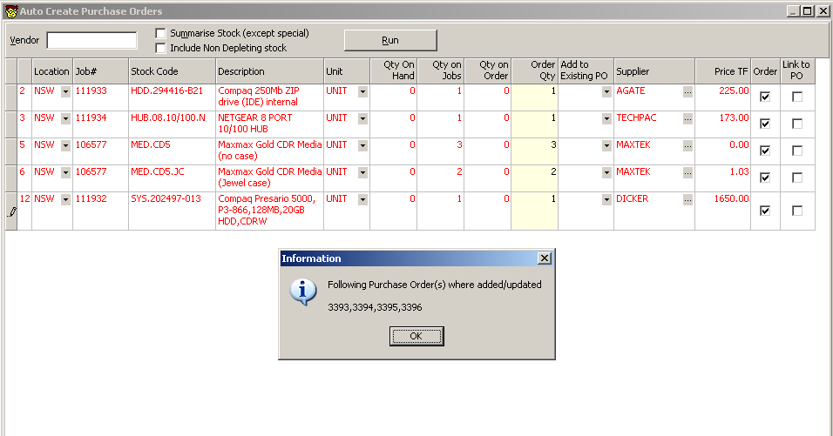

NOTE: Stock displayed in RED needs to be ordered (there is not enough stock on hand or on order to fill current Job requirements).

HINTS: Where you have certain vendors that you order from “every day” or very regularly, you can create a running Purchase Order to that Vendor then use the “Add to existing PO” column to continuously update the open PO until you are ready to close & place the order. The status of the running PO would remain on “Booked” (active) until it was “Ordered” (still active – eg:verbal additions made to supplier) then “Received” (no longer active – open a fresh order).

IMPORTANT THINGS:
As with all “Lists”, once RUN you have a specific snapshot of information to work with. The Auto Create Purchase Order form only works from this information (is not live).

We have created a matching “manual” report that uses the same calculation methodology as the Auto Create Purchase Order form – if you’d rather discuss first, review or raise PO’s manually, run your Job List and choose the “Job List – Required Stock For Jobs” report.

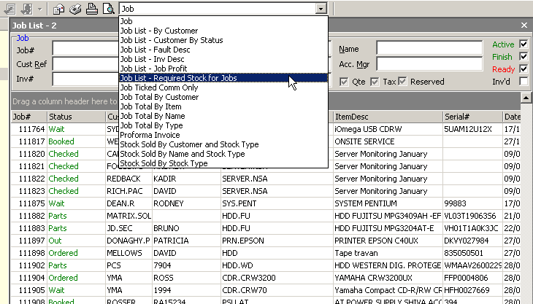

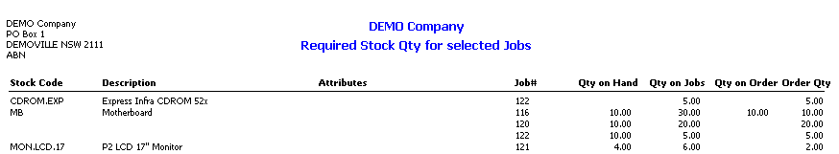

The Auto Create Purchase Order form works with specific Job information. The Stock Re-Order report (Management Report) uses stock record information such as minimum stock on hand counts, manufacturing requirements and so on. Your site may require a “combination” of reporting methods to cover all stock control needs. Feel free to discuss your exact needs with our Sales Team.

NEW - All Lists now save their Grouping/Order/Layout  return to menu

Version 2.10 gives you the freedom now to group, order and generally layout all your Lists, shut JIM2 BE then re-open to find all your Lists “saved” in their last format, ready to run again.

You can also remove columns by dragging the column header “off” the grid. Right click and select Grid Columns to add the columns back.

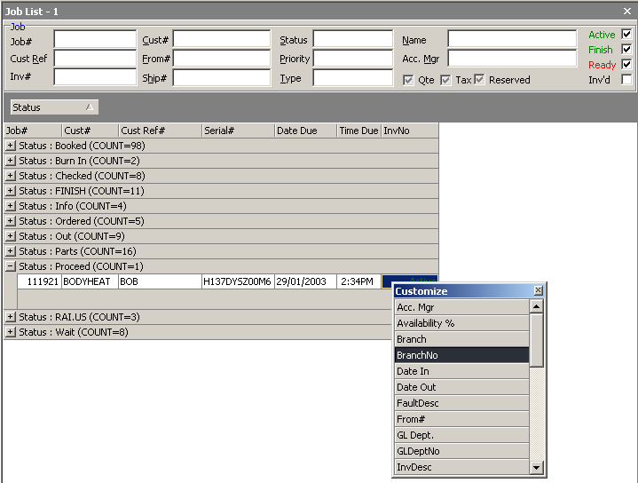

NEW - Receipt Printing reports  return to menu

In line with the new retail Option, we have designed 2 new standard report layouts to suit the most popular “receipt printer” formats.

- The 76mm report creates a point-of-sale receipt suited to DOT MATRIX printers (no graphics)
- The 80mm report creates a point-of-sale receipt suited to THERMAL printers (can contain graphics)

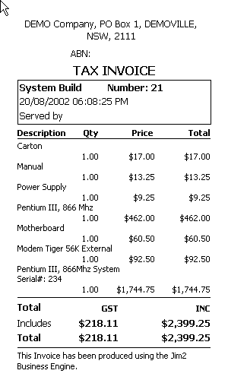

As with all JIM2 BE reports, these new reports will be included as part of the V2.10 upgrade. If you wish to modify/ customise these reports, this can be done via Report Designer.

NEW - Cash Draw control (Menu Script driven)  return to menu

The Retail option for V2.10 includes a new menu icon and associated script to signal the Till to open (outside the Invoice routine). If you are running Retail and your workstation is not showing the new Till icon (to the right of the report menu), you can activate the icon by right-clicking in the toolbar and choosing CONFIGURE or from the menu bar select View> Configure Scripts Menu. Select the associated script from the menu and Save.

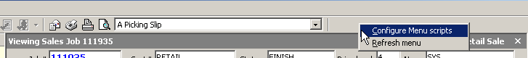

To open the Till drawer, click on the icon. Users will need to “authenticate” or identify themselves to the workstation (regardless of who is currently logged in) by typing their user initials[space]password at the prompt – then the drawer will open.

You may need to “import” the cash drawer script. If this is the case go to Tools> Scripting Engine> Script> Import.

NEW - Till reconciliation  return to menu

Monies being received/ recorded at the point of invoicing at each POS workstation will typically be stored in their respective Till (cash drawer). This includes all payment types (cash, cheques, EFTPOS etc). A complete record of each payment can be found in both the Till Reconciliation and Unbanked Funds.

At any time the contents of a Till can be reconciled against recorded payments. Typically this would be an end of day routine, but could be done to coincide with banking sessions (when you head down to the bank with cash, cheques etc). Till Reconciliations give you the opportunity to monitor accuracy at the POS and make any under/over corrections prior to actually banking the funds.

The process of Till Reconciliation works very much the same as a Banking Session. The purpose of the Till Reconciliation is to compare recorded takings to actual Till takings. To complete a Till Reconciliation:



Click on BANKING in the sidebar, then choose Till Reconciliation. By default, the “Select By” criteria for viewing transactions is set to “Not reconciled” – that is, you will be able to edit a list of all transactions recorded against the nominated Till# that have NOT been reconciled.

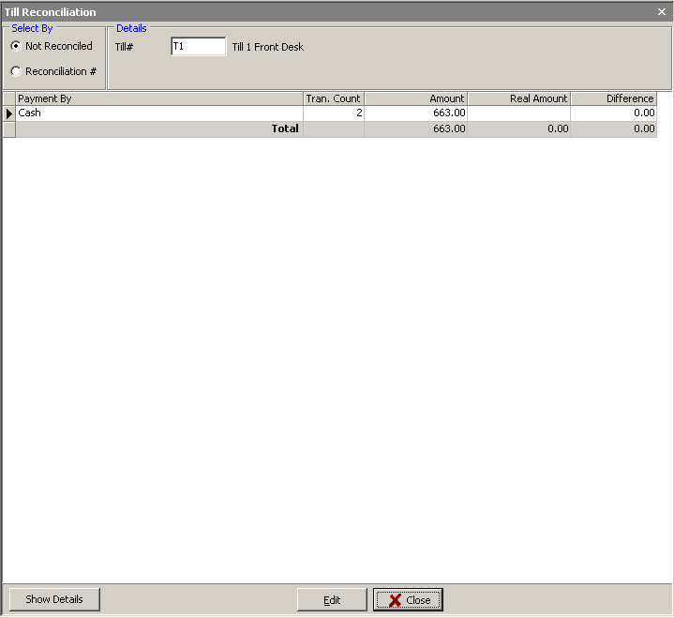

NOTE: To view previous reconciliation sessions, change the selector to Reconciliation# and choose a previous reconciliation session from the dropdown list.

Nominate the Till# you would like to reconcile and select EDIT. A summarised list of all transactions, grouped by their Payment Types and with a transaction count for each type, will be showing with a TOTAL for each Payment Type. If you would like to see a breakdown on the total for any Payment Type, click on the Show Details button at the bottom of the
screen.

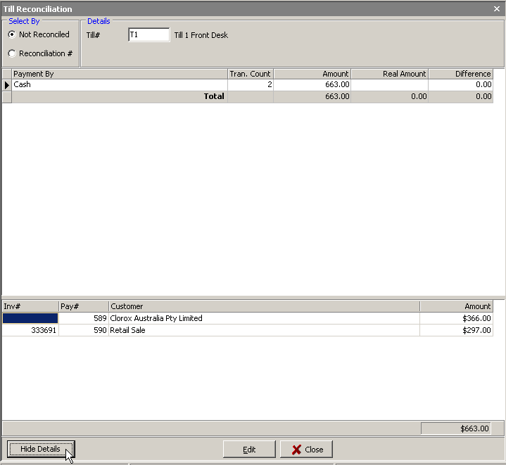

Having added/counted each Payment type total in the Till, record the “real amount” in the column with that header. If the “Amount” column matches the “Real Amount” column exactly, the line will turn green – indicating a fully reconciled total. If the “real amount” differs from the recorded amount, the “difference” (+/-) will be calculated and placed in the respective column with that name. This difference will become an “unders/overs” expense, and the + or – amount will now be showing in your Unbanked Funds.

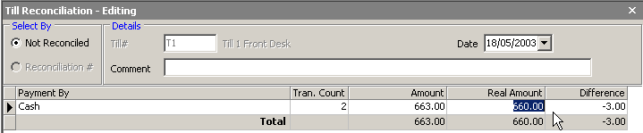

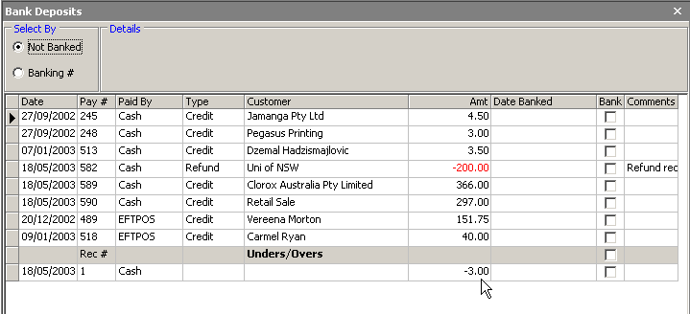

To finalise the reconciliation, select SAVE.

If for any reason you wish to “undo” and change a Till reconciliation, you will need to have adequate Security Level to do so. Re-call the Till reconciliation you wish to change using “Select By Reconciliation #”. Once the session is in view, choose the Delete Reconciliation button.
NOTE: if the monies have been banked in the meantime, they will automatically show as “green” (fully reconciled).

NEW - Cash Rounding  return to menu

If you do NOT have JIM2 BE set with the option to “round to the nearest 5 cents”, then coin (currency) denominations may limit your ability to tender EXACT cash change in some circumstances. Case in point: an Invoice totals $19.99. The customer gives you $20 cash as payment, and you will not be able to give the customer 1 cent cash change (you could choose to give them a 1 cent credit for next time…).

It is ”accepted” retail practice to round total invoices up or down to the nearest 5 cent for cash transactions. As such, if an invoice total ends in 1, 2 or 6,7 cents and the customer is paying by cash, JIM2 BE will automatically round the transaction down to end in zero or 5 cents respectively and move the odd cents to your new linked Rounding (expense) Account.

If an invoice total ends in 3, 4 or 8, 9 cents and the customer is paying by cash, JIM2 BE will automatically round the transaction up to end in 5 or zero cents respectively and move the odd cents to your new linked Rounding (expense) Account.

This rounding does not effect the Invoice total (or Debtor records) and does NOT take place for other payment types – just cash.

NEW - Invoicing Authentication Security  return to menu

For sites running Retail (in particular) and using the new “Fast Invoicing”, you can now use the new Invoice Authentication security check to ensure Invoices are logged specifically to the user invoicing – without the need for the user to log into the workstation.

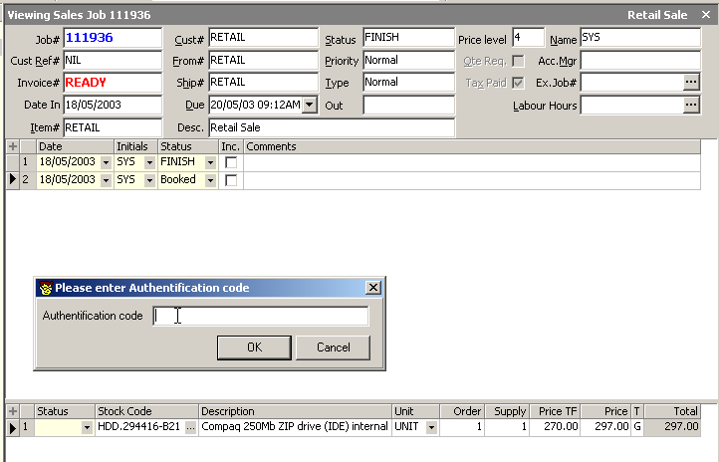

If this new Option is activated, at the point of Invoice (F6) users will be required to type in their JIM2 BE User login Initials [space] Password into a pop up dialog box. This authentication process will capture the name of the User, and record it within the invoice header.

NEW - RTV when PO is on received  return to menu

The reverse process to a Purchase Order is the Return To Vendor. In strict FIFO fashion, you should not be able to “return” stock from a Purchase until you have finalised (Finish) the Purchase.

However… there are circumstances where you may have “received” the Purchase Order and would like to RTV immediately. What you need to be very clear on here is that:

Receiving a PO Qty count for stock increases but COGS, GST and Creditor are pending until PO is Finished
Finishing a PO COGS, GST and Creditors is updated.
Return to Vendor Qty on hand reduces, GST paid is reversed, creates a Creditor credit.

We now allow you to ADD a Return To Vendor against a PO that is still on “received” BUT you won’t be able to FINISH the RTV until the PO is also finished. It is a good compromise!

NEW - New Stock On Hand/ Committed/ Available  return to menu

We have made significant enhancements (internally to the software) in the way Stock quantities are calculated and handled internally within Jim2. The result of this is that the reported availability of Stock can be tailored to suit your business model.

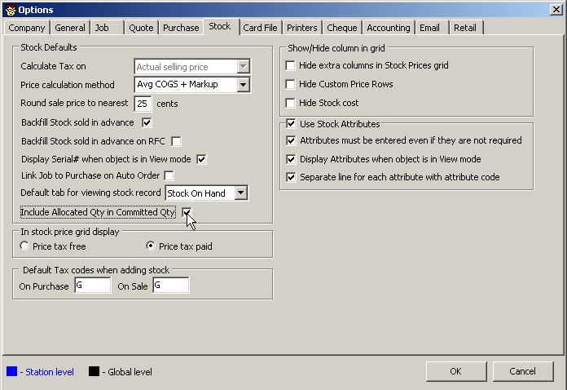

The Qty by Locations grid has been updated to include…
Qty on Hand | The actual (countable) quantity of stock on hand
Committed | The quantity of stock committed. The committed quantity is being calculated in one of two ways depending on the ‘Include Allocated Qty in Committed Qty’ option you have selected in Options> Stock.  If this option is ticked, this value includes stock on Jobs that are on Reserve and/or Ready PLUS stock in the order Qty of Jobs.  If this option is unticked, this value includes stock on Jobs that are on Reserve and/or Ready.
Available | The quantity of stock available. The Available quantity is being calculated in one of two ways depending on the ‘Include Allocated Qty in Committed Qty’ option in Options> Stock.  If this option is ticked, this value includes stock on Jobs that are on Reserve and/or Ready PLUS stock in the order qty of Jobs.  If this option is unticked, this value includes stock on Jobs that are on Reserve and/or Ready.
BackOrder | Amount of Stock that is in the BackOrder column of Jobs

For example… where 5 of this stock are allocated to Jobs, but not Reserved and/or Ready.

Include Allocated Qty in Committed Qty (Stock Option) | Qty on Hand | Committed | Available | BackOrder
Ticked | 12 | 10 | 2 | 2
Unticked | 12 | 5 | 7 | 2

NEW - Stock Availability by Location (on the fly)  return to menu

If you have multiple stock locations and are adding Stock to a Job, we now give you the choice to view Available Stock from a different location on the fly. By default, users are “linked” to one specific location when selling. As you add Stock quantity to the Stock Grid, Jim2 will calculate the available Stock from that location. However if there is insufficient in your default location, you can view stock levels in alternate locations.

On any entry in the Stock Grid you can use the Available Stock Lookup (F5) to show availability of that Stock in your default location. We now give you the choice to select an alternate Stock Location using the Location dropdown.

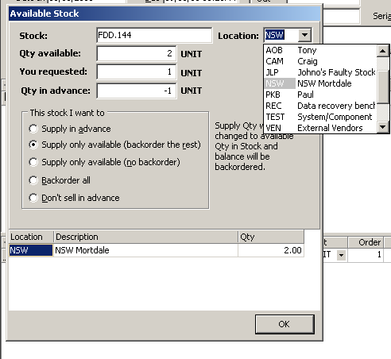

NEW - Quick Login mode  return to menu

Logging in and/or changing users now simply loads the user’s options and security settings rather than reconnect to database and hence makes changing users much faster.

NEW - Event Scripts  return to menu

“Out of the Box” you will not need any Event Scripts to run JIM2 BE. However, if your site has very specific requirements or refinements needed we can create Event Scripts for you to handle these changes. Event Scripts are activated by existing JIM2 BE “events” such as status changes. An Event script example would be:

If Job status changes from Booked to Confirmed, then on “save” change the Job due date.

We’re sure you’ll agree this is a very significant enhancement for JIM2 BE. Event Scripts do not interfere with the core engine functionality of the product – so the whole product becomes incredibly flexible. Contact our cheery sales team for information and quotes on producing Event Scripts for your needs sales@happen.biz

NEW - Menu Scripts  return to menu

Menu Scripts are another new addition to JIM2 BE. Menu Scripts “hook” actions to the mouse-click on menu icons. A good example of this is the new Till icon we have created for the Retail option. By importing the Till menu script, a new icon will appear in your Toolbar. When you “click” on this icon, it activates a menu script that open a dialog box ready for user authentication (security) and then sends a signal to open the Till drawer.

Another example of Menu Scripts would be to create an icon that when clicked, pints a specific list of management reports.

Again, this type of technology enhances the functionality of JIM2 BE significantly, and helps you tailor the system more to your individual requirements. Again, contact our cheery sales guys for information and quotes on producing Event Scripts for your needs sales@happen.biz

NEW - Negative Banking (cash refunds etc)  return to menu

To support the processing of REFUNDS, you can now nominate to “allow negative” transactions on any or all of your Payment Types. To change Payment Types to allow for negative transactions, open Setups>Payment Types and edit – check the “allow negative” tick box and save.

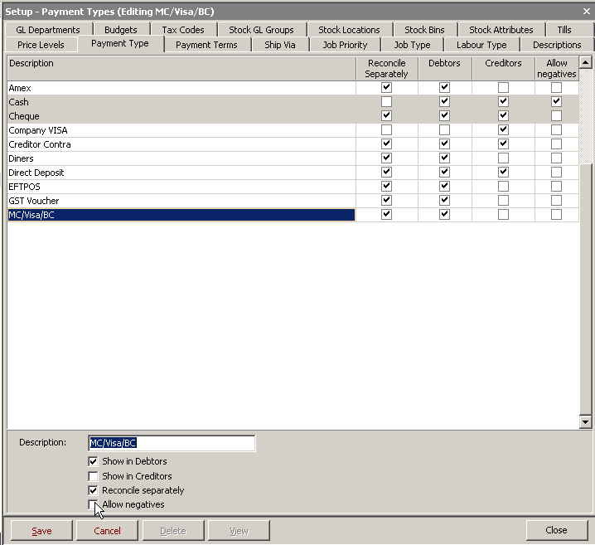

Because payments (via Debtors or Invoice Payments grid) move to Unbanked Funds, Debtor REFUNDS (negative monies) will reduce the $ total available to Bank. By making specific Payment Types “allow negatives” you can now process a Debtor Refund using these Payment Types. The “negative” $ will appear in your Unbanked Funds list, ready to Bank to your nominated account.

EXAMPLE: If your Unbanked Funds of “cash” for the day is $1000 (+) and $100 (-), by checking both transactions you will be Banking $900 (+) cash. In this example, you would have recorded $1000 in Debtor payments, and recorded $100 in Debtor Refunds.

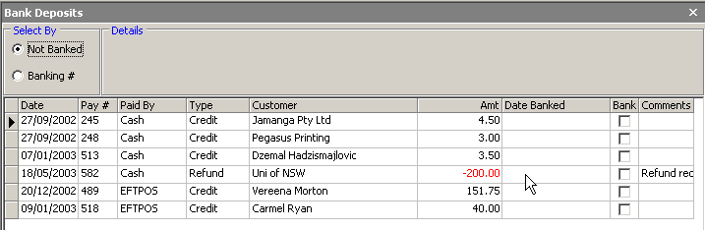

NOTE: if you are processing a Debtor refund via a Retail Till, you can nominate “which Till” the refund is being made from. The negative transaction will appear in that Till Reconciliation. If the refund is being made via any other workstation (ie: not connected to a Till), you do not need to nominate a Till, and the negative transaction will go Unbanked Funds. There are on screen prompts to help you record these refunds correctly.

NEW - ‘From’ supported on Purchase Orders  return to menu

This new feature has been included to help sites that need or use vendor “central billing”. The VENDOR# nominated on any Purchase Order will ultimately become the “creditor” in a Purchase. However, the stock may be supplied FROM# another company all together.

Another great use for this feature is when you or your staff “purchase” stock using their own money. You can raise a Purchase order to them - “Vendor” - and nominate the place of purchase - “From”. For example: Paul buys goods from Officeworks using his own money. Raise an Expense Order to Paul (becomes the Creditor) where FROM = Officeworks. Re-imburse Paul using your normal Creditor payment method!

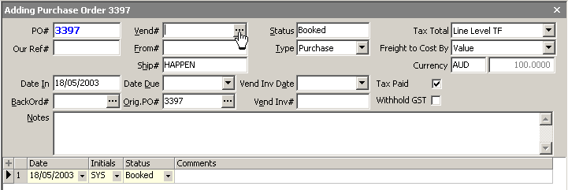

By recording Purchases this way, you can then search and create Purchase Order Lists using the FROM# (rather than the VEND#). As such, we have moved the PO List search focus from VEND# to FROM#.

HINT: For central billing CREDITOR payments, you can use the VENDOR INVOICE# column to quickly identify which FROM# supplier bills you will be paying for any given period.

NEW - Shortcuts keys  return to menu

F6 If using “fast invoicing” the F6 key will start the Invoice process (change Job status to Finish & open invoice payment grid, ready to record payment .
F9 will “OK” the payment and start the print process (in retail mode will also open cash drawer)
Ctrl F Pressing Cntl F allows you to search in most Grids (was Cntl Z)

The existing Function Keys for all you keyboard jockeys!
F1 Help
F12 View Edit a Job

Objects - Functions keys
F2 Header
F3 Comments grid (where there is a comments grid)
F4 Stock grid
F5 Stock Select grid and also the Serial Number selection and/or entry screen
F9 Edit or Save selected document (not save and close that's F11)
F11 Save and Close selected document (closes the document from the Nav Tree)

Some Function keys change their use when in Lists (except Stock Transfer and Stock Adjustment Lists)
F2 Opens the selected record in view mode
F9 Opens the selected record in edit mode

In Jobs
F7 In Jobs - Labour Entry
F8 In Jobs - Marks the Job as ready to Invoice

ESC To cancel out of a window/dialog box
Ctrl Z Undo last action
Ctrl F12 Log Out of Jim2.

NEW - Auto BCC email  return to menu

As you are no doubt aware, Jim2 BE includes the option to email information from within object forms (such as the comments grids) and to email reports. To enable email, Jim2 BE uses the SMTP setting and port address for your server you have entered in Options> Email.

Further to this, we now include the option to automatically Blind Carbon Copy (BCC) anything emailed from Jim2 BE directly to your nominated email address. This function is setup via the User CardFile tab. To activate the BCC option:

- Open a User’s CardFile record and select the USER tab.
- Enter the user’s email address in the Email field
- Check the Auto Send BCC tickbox to activate.

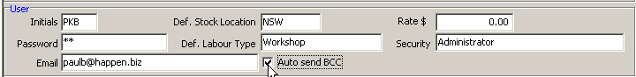

The BCC document will appear in the user’s email “Inbox” (rather than Sent Items). SPECIAL NOTE: this function is dependant on how Microsoft Exchange has been configured for your network. You may wish to discuss this with your network administrator – or pop an email through to support@happen.biz for some technical hints & tips on settings for MS Exchange.

NEW - Support of the Cash GST method  return to menu

The development of the GST Sessions that can cope with the CASH reporting method makes JIM2 BE the premier product for tax calculations on the market! Extensive trials and testing have been done prior to the release of this feature to ensure our CASH reporting sites can be completely confident in using GST Sessions to calculate their BAS liability.

If you have selected CASH GST CALC in Options, the GST Session will show the following transactions at each tab:

SALES the payments +/- allocated to sales transactions (excluding the exact portion of that payment that was any stock flagged with the tax code X)
PURCHASES the payments +/- allocated to purchase transactions (excluding the exact portion of that payment that was any stock flagged with the tax code X)
PAYG the transactions flagged with tax code P & Q
EXCLUSIONS the portion of payments allocated to Sales and Purchases that did not attract tax as well as any other transactions using the tax code X.
OPENING BALANCE INVOICES & PURCHASES

To complete the GST Session, you will use the same Selection method against transactions as described above.

Further additions to Stock Attributes.  return to menu

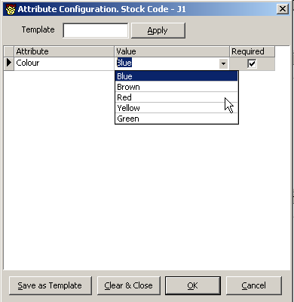

Attribute Selection can now be done “in advance” from the Job Form – that is, you can effectively pre-select the Stock Attributes you would like to sell – and this information will come forward into the Purchase Order.

The Attribute Configuration grid and Attribute Template grid ensures all users can only select and sell specific attributes for specific stock.

The Stock Form STOCK ON HAND and STATS tab can be set to “show attributes” or not.

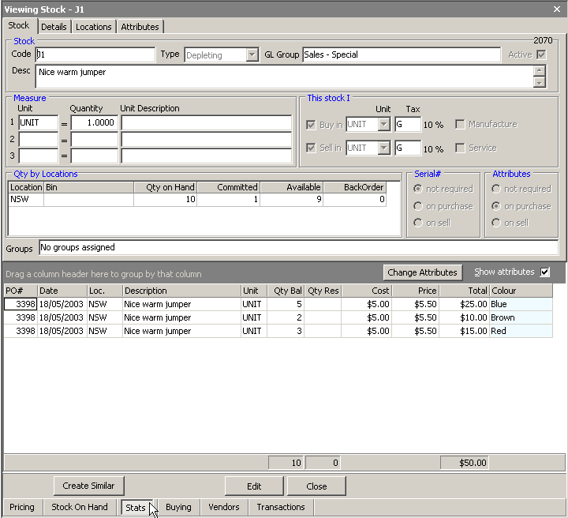

Further enhancements to Debtor Statements  return to menu

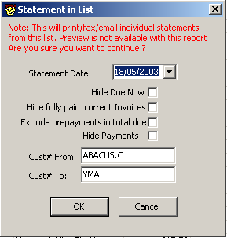

The enhancements to the Debtor statement methodology allows you to effectively pre-select the range and information on Debtor Statements prior to sending them out. Looking at the selection criteria above, they can be used in ANY combination to produce all or batched Statement runs. You can set any combination of these new checkboxes as “default” using Global Variables

TIP: You can of course pre-sort Statements using the Debtor List criteria, then use these Statement List criteria to further personalise your Statement information.

Additional Search fields in Quote List  return to menu

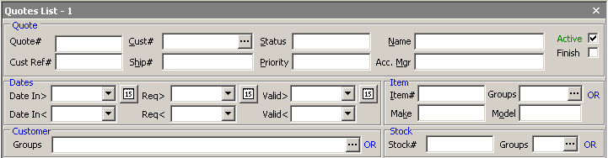

The standard search criteria has been enhanced to include all of the following “search” fields, in any combination. This aligns the Quote search more closely with the Job search pattern.

Unprinting Invoices allows Payments to be reversed  return to menu

This version of Jim2 BE allows you to reverse both the Invoice process AND any allocated payment at the same time. Reversed payments will be removed from “Unbanked Funds”.

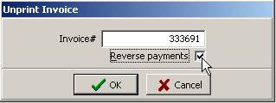

Stock Form enhancements  return to menu

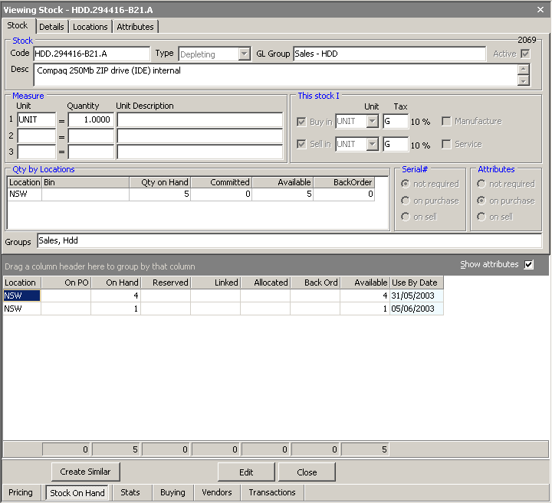

Version 2.10 includes changes to the layout and information contained on the Stock Form tabs. This includes more detailed information on the STOCK ON HAND tab – including the option to show Attributes.

Job List Enhancements  return to menu

Date Due
The Job Date Due column has been split into separate date and time columns allowing easy grouping by date etc.

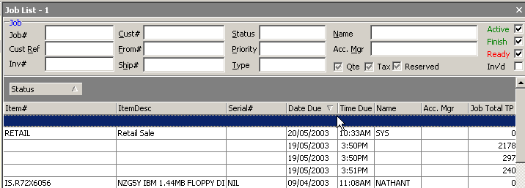

Debtor Refunds from Unbanked Funds  return to menu

Refunds are now allowed Unbanked Funds on selected Payment types. This allows you to do cash refunds from your Till when using Jim2 in Retail mode.

It is recommended that Cash and Credit Card payment types be enabled to allow for refunds from Unbanked Funds by marking these payment types as ‘Allow Negatives’ in Tools / Setups/ Payment Types. This allows for cash refunds from your Till and Credit Card refunds to be held back in Unbanked funds until they are confirmed thay have hit your Bank account.

Refunds from unbanked funds will appear as negative amounts in Banking.

NEW Options  return to menu

As you all know, Options are used in combination to create “default” conditions or behaviour in Jim2 – allowing it to be used in a wide variety of industries, and giving you the flexibility to change your workflow methodology as your company needs grow and change. Options can be selected (or not) or reselected at any time.

In line with the fantastic new features of version 2.10, we have included the following NEW Options that can be activated. Please read through the following notes to help with your selections:

OPTIONS – GENERAL  return to menu

New option allows you to select your National Currency. This is in preparation for our upcoming Foreign Currency release.

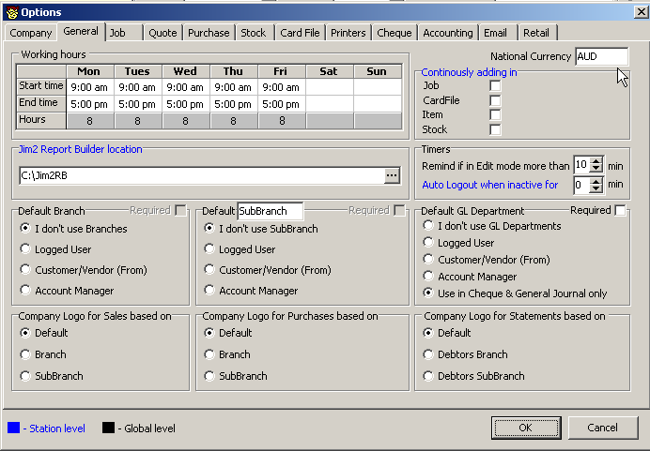

OPTIONS – JOBS  return to menu

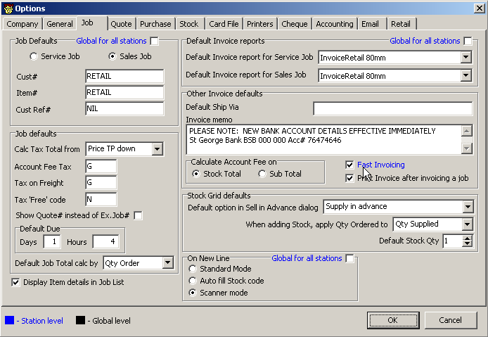

Fast Invoicing is designed specially for use in Retail but is equally useful on it’s own. When enabled, this station level setting will:
- Automatically move focus to Stockgrid (when default Cardcode, Cust Ref and Item defaults are in place) allowing immediate adding of stock.
- Automatically mark a job as FINISH when invoicing.

On New Line

This new option defines what happens on entering a new stock line in the JOB STOCKGRID:

Standard mode | Classic Jim2 mode (default)
Auto fill stock code | On entering a new line automatically add the stock code from the line above. Useful in high distribution sites where you are entering the same Stock Code (with different attributes for example) on many lines. By default the Code is selected so you can simply press Enter to accept the code or type in a new Stockcode.
Scanner mode | A new mode specifically for retail. Open entering a Stockcode (or scanning it) Jim2 will automatically add the line and automatically add a new line ready for adding additional Stock.

Note: This setting is Station Level by default and can be made Global by ticking Global for all Stations tickbox.

OPTIONS – PURCHASE  return to menu

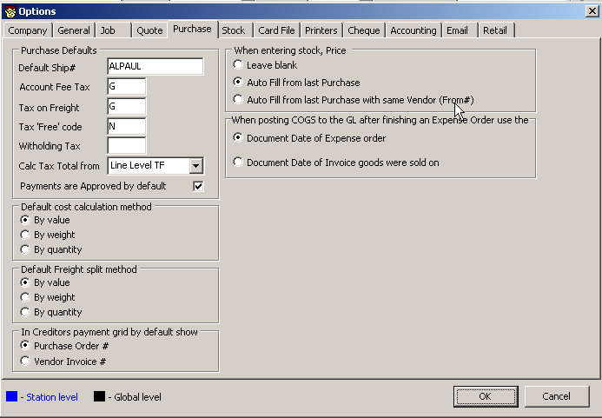

‘When entering stock, Price’ option has been updated to auto fill from last Vendor (From#) to use the From# instead of the Vendor code.

OPTIONS - STOCK  return to menu

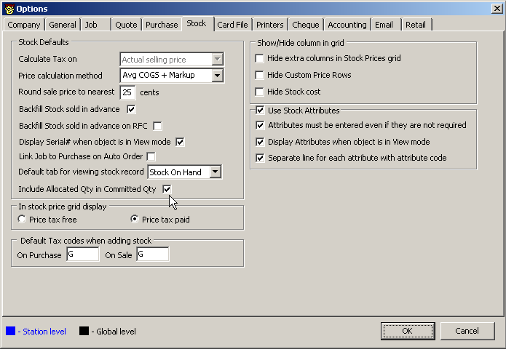

Link Job to Purchase on Auto Order
In line with the new “auto Create PO” function, we have included a new checkbox in the Stock Options that when checked, automatically “links” Stock to a Job whilst auto-ordering. This default can of course be over-ridden at the Auto Create PO screen.

Include Allocated Qty
A new Option, Include allocated Qty in Committed Qty allows you to indicate if you want the Supply Qty on Jobs to be included in the Allocated Qty.

Include Allocated Qty in Committed Qty (Stock Option) | Qty on Hand | Committed | Available | BackOrder
Ticked | 12 | 10 | 2 | 2
Unticked | 12 | 5 | 7 | 2

Stock - Attributes
Stock attributes options have been updated as follows…

Attributes must be entered even when they are not required. | When this option is ticked you must physically select that no attributes are required for this stock
Display Attributes when in view mode. | Display attributes in stock description by default.
Separate line for each attribute with attribute code. | When displaying attributes in Jobs, Purchase Orders etc use a brief description of the attribute and value or a detailed description of each attribute and associated value along with a new line for each attribute.

OPTIONS - ACCOUNTS  return to menu

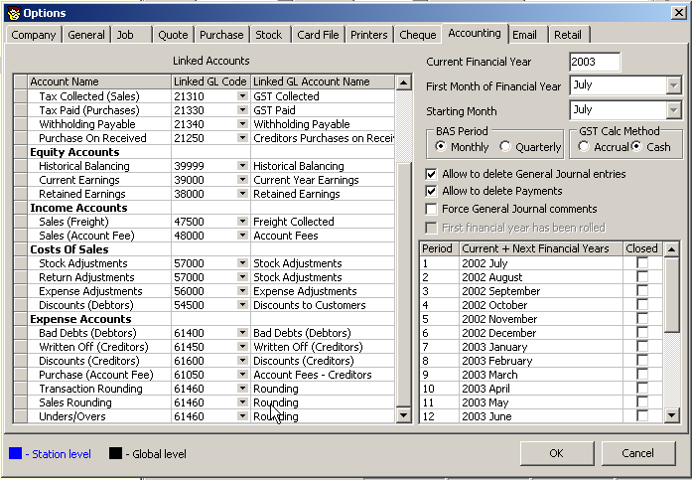

Linked Accounts
The linked account ‘Rounding’ has been renamed to ‘Transaction rounding’. This account is used to handle any rounding errors that may occur when posting to the General Ledger.

A new Linked account, ‘Sales Rounding’ has been added. This account is used to track the cents when a customer is paying by Cash. For example, the Invoice total is $19.99 and the customers gives you $20.00. The 1 cent difference is posted to this account.
It is recommended that this account be flagged as a Control account.

A new linked account, ‘Unders/Overs’ has been added. This account us used to record any differences between the real and actual amounts counted when doing a Till reconciliation.

By default the V2.10 update script links the ‘Sales Rounding’ and ‘Unders/Overs’ accounts to the existing ‘Transaction Rounding’ account. It is recommended that new GL accounts be created for and linked to the ‘Sales Rounding’ and ‘Unders/Overs’ accounts.

GST Calc method
A new option has been added that allows you to select either Accrual (default) or Cash GST reporting methods.
This option has been added to the Jim2 startup wizard.
Note: It is important that this option be select PRIOR to finishing your first GST session.

OPTIONS – RETAIL  return to menu

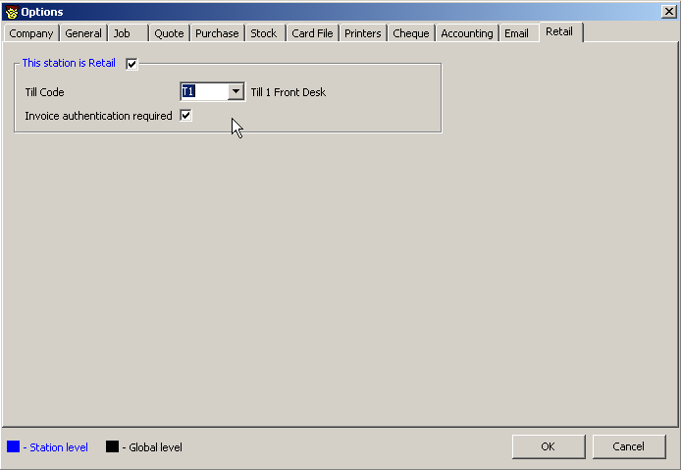

NOTE: This new options tab is enabled when Retail is enabled in your Jim2 key file.

This Station is Retail | Tick this to enable Retail on this Workstation
Till Code | Select which Till this Workstation is linked to. Tills are entered and maintained via Tools / Setups / Tills.
Invoice authentication required | When ticked User’s are required to enter their Initials and password at point of Invoicing regardless of who is currently logged into to that Workstation.  The format for entering this is your Initials followed by a Space followed by your Password.

NEW SETUPS  return to menu

Payment Types
A new column, Allow Negatives, allows you to flag individual payment types as refundable from Unbanked Funds. Be careful here to only flag those Payment Types that your Retail Staff can use for refunds.

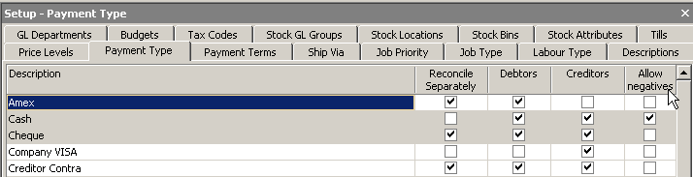

Tills

As part of the Setup to operate Retail, you will need to firstly name the Tills you use (Code and Description), then assign each Retail workstation one of these Tills. You can of course have two workstations using the same (physical) Till. Allocation of Tills is done via Options> Retail.

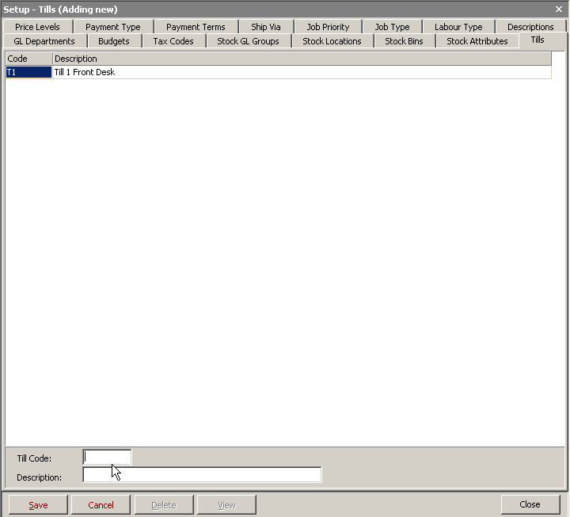

Security  return to menu

Security has been re-organised to match the new interface changes and additional functionality. Important - Please review them and adjust them accordingly as they are ENABLED by default.

Area | Security Option
CardFile | Change Card Codes
Items | Change Item Codes
Stock | Change Stock Codes
Stock | Change Stock Attributes
General Ledger | Change GL Codes
Tools | Allow exporting data

Reports  return to menu

Many reports have been modified to handle the new changes. If you have any custom reports or scripts which fail for some reason please contact support@happen.biz or any of the Happen Business team.

The following GLOBAL VARIABLES can be added and used to “default” changes into the Statement in List select:

Jim Global Variables | Type | Value
StatementHideDueNow | boolean | true
StatementHideFullyPaidCurrent | boolean | true
StatementExcludePrepaymentsInDueNow | boolean | true
StatementHidePayments | boolean | true

The following Global Variables can be now ADDED to change current defaults on existing Invoice & Quote Reports:

Jim Global Variables | Type | Value
InvoicePrice | string | PriceTP (change to TF to show ex GST)
InvoiceShowDiscount | boolean | false (change to true to show discount column)

Fixes and Improvements  return to menu
The following issues have been resolved – Please report any issues if you find them:

- Better Email error handling.
- Better reporting of errors in the Jim Log

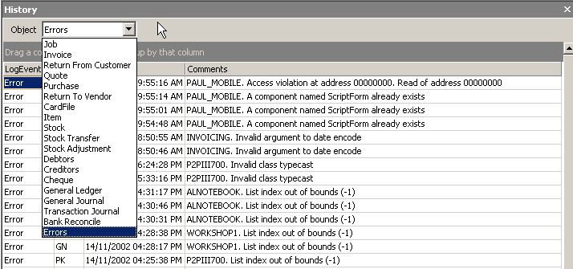

Conclusion
As usual, we have had lots fun creating this new version and we trust you enjoy the new features and updates and find them of practical use within your business.

We would especially like thank all those you participated in our Release Candidate Program.

Thank you for your continued support. We welcome ALL feedback and suggestions, and we actively use your input to continue to develop our products.

Thanks

The Happen Business Team

NEW - GST Sessions  return to menu

To enhance the BAS experience (!) we have now introduced a fantastic new feature called GST Sessions. The choice of CASH or ACCRUAL reporting methods for BAS needs to be selected in Options> Accounting> GST Calc Method. Your reporting FREQUENCY needs to be selected in Options>Accounting>BAS Period.

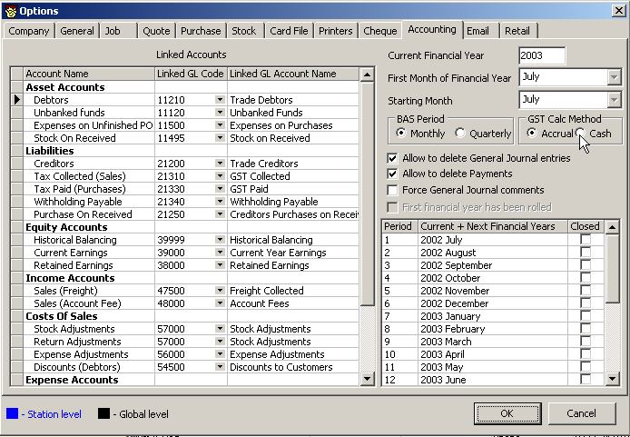

The GST Accrual method looks for the total dollar value +/- of Sales, Purchase and PAYG transactions within a given period that are flagged with reportable tax codes.

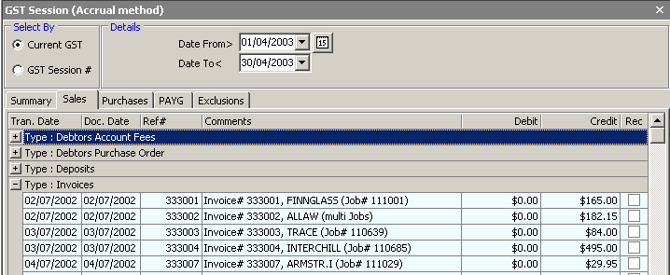

The GST CASH method looks for the total dollar value +/- of payments applied to Sales, payments applied to Purchases and PAYG transactions within a given period that are flagged with reportable tax codes.

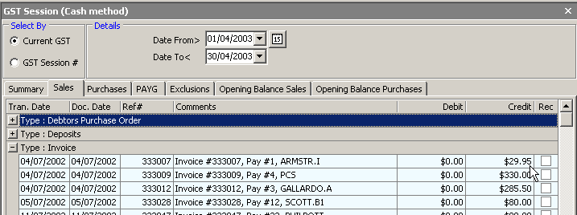

NOTE: When using either GST Sessions OR the Management Reports for GST, the “frequency” set in Options will default the current reporting dates to the session or report. You can of course over-ride the default dates. If you need to report GST “quarterly” and PAYG “monthly, your frequency “default” should match one or the other, and the session/report date range then changed as required.

The function of the GST Session (Cash or Accrual) is to help you SELECT the transactions you should report, then calculate your liability to match those selections. You will literally be “reconciling” your transactions. Selected transactions will then be calculated and added to your GST Summary Calculation Sheet, and you would use this information to complete your BAS report. By selecting them in a session and SAVING that session, they will NOT appear in the next GST session (they have been reported).

To make the selection process as easy as possible, we give the option to:
- Select ALL transactions (Sales, Purchases, PAYG) found for the given period in one hit
OR
- Select all Sales, then all Purchases, then all PAYG transactions found that need to be reported for the date range selected.

- Further to this, you can choose to “unselect” specific Sales, Purchases or PAYG transactions. Unselected transactions will NOT be used in the Summary Calculation Worksheet, and would move to the next BAS Session. This “select’ or “unselect” of transaction will help smooth out your GST Adjustment entries.

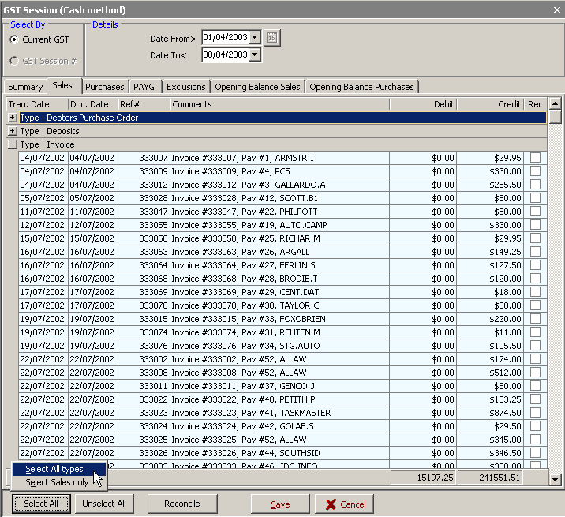

You will see in the GST Session that there is a fourth tab called “Exclusions”. This tab will show you a complete list of all transactions that have been flagged with the tax code X that fall within the date range. As tax code X transactions ARE NOT reported, we list them there for you to “review” prior to reconciling the GST session. If you would like to check any of the Excluded transactions (perhaps they should have been a different tax code) you can right click and drill directly to the transaction to check it. If you find it has been marked with tax code X in error, you would undo/reverse the transaction and correct its tax code, then run the GST session again (it will have moved to the correct reporting area).

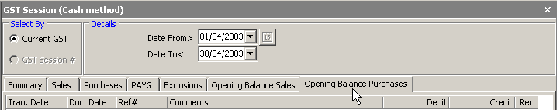

The last two tabs have been included to assist with reporting the GST requirements when “going live” with Jim2 and/or when accepting & making payments (Cash method) against Opening Balance Debtor & Creditor transactions. For the latter, Jim2 will report the entire transaction amount. You will need to check in your retired software “how much” of the transaction total attracted GST and adjust your BAS report accordingly.

VERY SPECIAL NOTE:
The GST Management Reports were designed for ACCRUAL method ONLY and selects ALL transactions automatically and uses these transactions to calculate your liability. It does not “reconcile” transactions. The V2.10 upgrade script will rename all legacy GST reports as reportname(old) automatically.

The GST Session is designed for use in either CASH or ACCRUAL method and gives you the opportunity to review and select/deselect the transactions you would like to use to calculate your liability. Saving a GST session “reconciles” the selected transactions. Unselected transactions or “out of period” transactions will then move forward to the next GST Session.

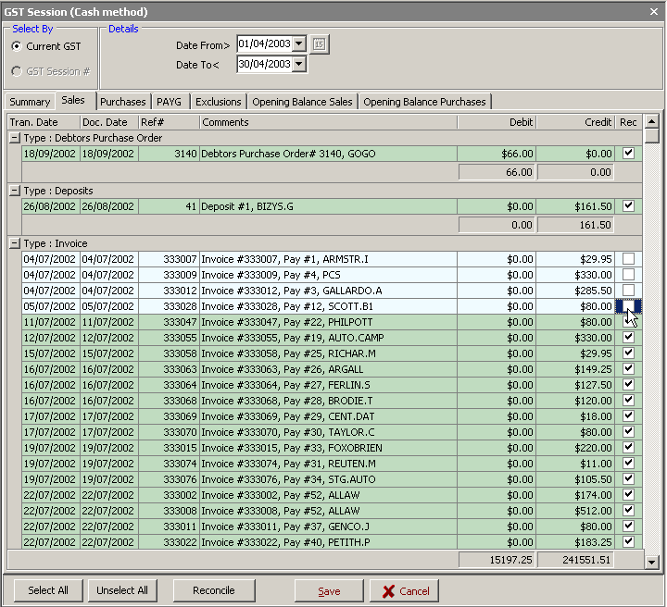

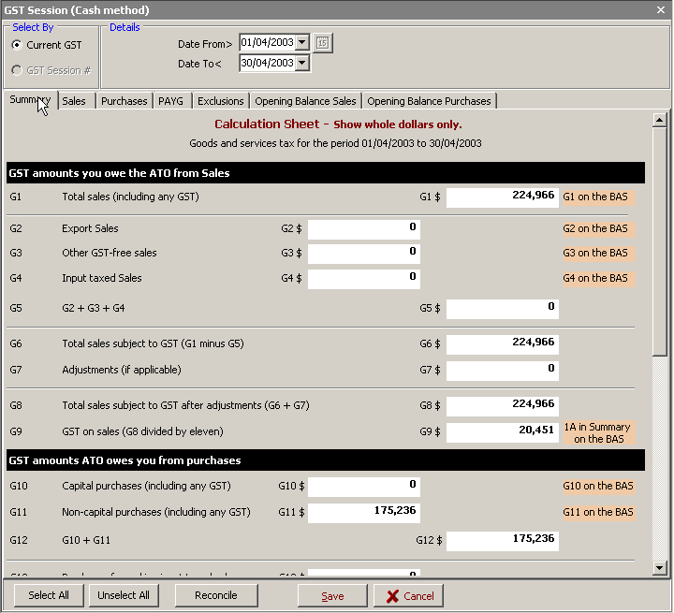

INTIAL GST SESSION

Regardless of the GST Reporting method used (Cash or Accrual) sites that have been using Jim2 for quite some time will need to complete an “initial GST Session” to clear away all the transactions you have previously reported (so you don’t double up on reporting & to clear out the historic transactions to make subsequent sessions easier to manage).

To do the initial GST Session, make sure your Option for GST Calc Method has been correctly selected. This will have a direct effect on the information presented in the GST Session grid.

For the INITIAL GST Session:
- Select the GST Session icon found under Accounts in the sidebar.
- Change the date range for the session to Date From>when you commenced transactions in JIM2 BE and Date To< your last BAS finish date.
- Select EDIT to open the session
- Use the Select All (& Deselect if necessary) on the transactions to match your reported totals to date. You can choose to do period by period initial sessions to match your historic BAS reports.
- You can SAVE your session along the way.
- When you are happy with your session (the Summary worksheet matches your previous BAS submissions) select the RECONCILE button to clear those transactions away.

The last two tabs will appear only if there have been payments made (Cash method) against Opening Balance Debtor & Creditor transactions. Jim2 will report the entire transaction amount. You will need to check in your retired software “how much” of the transaction total attracted GST and adjust your BAS report accordingly.

To view a previous GST Session, change “Select By” to GST Session# and choose a session from the dropdown list. When viewing a previous session, you can choose to DELETE that session using the Delete Session button. This will return all those transactions back to the GST session and you can re-do the session.

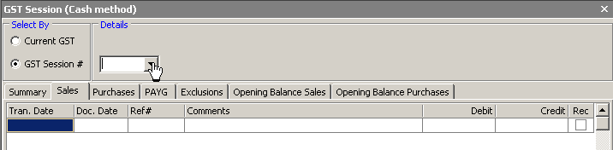

NEW – Retail (Option)  return to menu

OVERVIEW
To use the Retail Option in JIM2 BE, you will need to upgrade to version 2.10 that includes the new RETAIL Option:

- Identify which workstation(s) are to be used in your retail area. Using OPTIONS and SETUPS you can “link” specific workstations to your TILL(s).
- The Till’s cash drawer is activated once the Payment has been entered for each Invoice.
- You will be using specific shortcuts to “speed invoice” – default CARDCODES and ITEMS for the Job form itself, and keyboard shortcuts (F6) to FINISH and INVOICE in one move.
- The cash drawer Docket printer will be setup as an “Extra Printer” – extra printer#3 for the linked workstation(s). The modified Invoice report INVOICE.POS to suit 76mm or 80mm printers will be set to be picked up by default when invoicing through a POS workstation. You can of course choose to print/reprint to any of your other network printers using the standard A4 format Invoice reports.
- You can reconcile the amounts from the Till as part of your end-of-day routine and make minor adjustments to cater for unders/overs prior to doing a normal Banking Session against Unbanked Funds.

HARDWARE REQUIREMENTS
Your Retail Workstations would ideally include access to:
- A Cash Drawer (Till)
- A Docket/ Receipt Printer (76mm or 80mm roll)
- A barcode scanner

However, you could operate a Retail Station without these. Hardware specifications and recommendations can be made by contacting the Happen Sales Team on (02) 9570 4696.

OPTIONS & SETUPS
Open JIM2 BE TOOLS>SETUPS and click the TILLS tab. Choose ADD to create and give each TILL a unique CODE & DESCRIPTION.Save & Close.

From the workstation(s) in your retail area you would like to use with a TILL follow all these OPTION steps:

In OPTIONS move to the RETAIL tab.
- Tick the checkbox “This workstation is Retail”.
- Nominate the TILL CODE to be used for that workstation.
- For those sites where you would prefer to identify exactly which user is Invoicing (rather than changing login for each user as they execute a sale) tick the checkbox “Invoice authentication required”. At the point of Invoice, any user will need to identify themselves with their “User Initials [space] Password” and press Enter before the sale is processed.

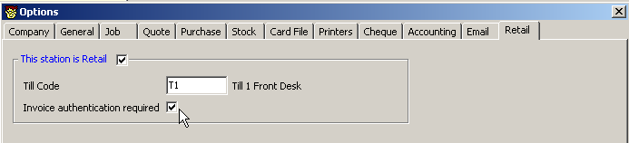

In OPTIONS, move to the JOB tab.
At the Job Defaults section:
- Untick the “Global for all Stations” checkbox.
- Set the default CUST# to your preferred generic code (example: RETAIL)
- Set the default ITEM# to your preferred Item code (example: RETAIL SALE)
- Set the default CUST REF# to a preferred generic term (example: RETAIL)

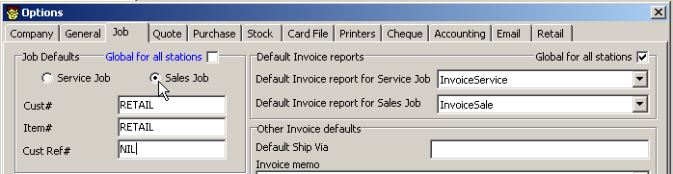

Special notes here: These defaults will automatically populate the Job form, and the cursor will be active in the Stock grid of your Sales Job, ready to type/scan stock codes. In some instances, you may want to invoice a customer who has “trading terms” (will not be paying at the point of sale). To activate specific customer trading terms on a retail job, you will need to highlight and change the default CUST# RETAIL to the CUST# of the actual customer – this will also create a more personalised invoice for the customer.

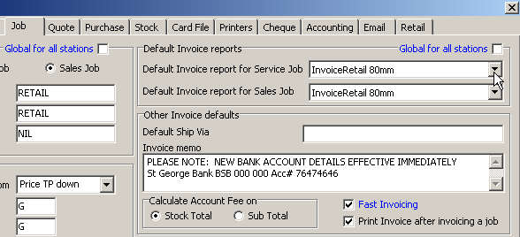

At the Other Invoice Defaults section:

- Tick the checkbox for Fast Invoicing (this enables the auto status change to FINISH & opens the Invoice screen at the Payment Details tab, ready for you to record the customer’s Payment Type – cash, credit card etc). The F6 function key will be used for “fast invoicing”.

- Untick the “Global for all Stations” tickbox in the default Invoice reports section. For the Default Invoice report for Sales Job choose the INVOICE.POS report IF you are going to use a 76mm or 80mm docket printer at this station.

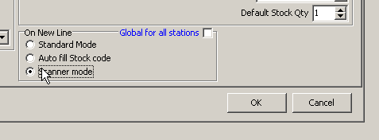

At the On New Line section:

Standard mode | Classic Jim2 mode (default)
Auto fill stock code | On entering a new line automatically add the stock code from the line above. Useful in high distribution sites where you are entering the same Stock Code (with different attributes for example) on many lines. By default the Code is selected so you can simply press Enter to accept the code or type in a new Stockcode.
Scanner mode | A new mode specifically for retail. Open entering a Stockcode (or scanning it) Jim2 will automatically add the line and automatically add a new line ready for adding additional Stock.

In OPTIONS, move to the PRINTERS tab.

1. In EXTRA PRINTER #3 nominate the Tills Docket printer if you are using a POS drawer and 76mm or 80mm docketing printer.

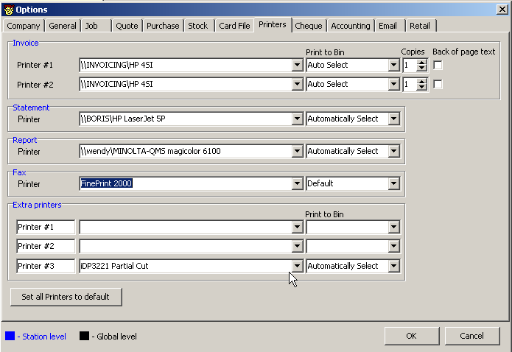

OK all these Option changes – and remember to repeat this at each RETAIL WORKSTATION.

GENERAL LEDGER CHANGES

There are General Ledger changes that automatically happen when you upgrade to V2.10. These changes accommodate the new functionality required for the new Retail option (POS) rounding & recording of unders/overs in Till takings. Although the upgrade will have your General Ledger functioning correctly, it is recommended you review the following notes, and make any changes to your Chart of Accounts as required.

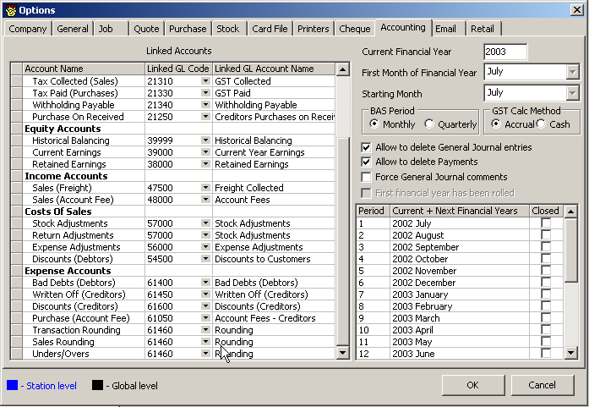

The LINKED ACCOUNT ‘Rounding’ has been renamed to ‘Transaction Rounding’. This account is used to handle any rounding errors that may occur when posting to the General Ledger. Linked Accounts are used by JIM2 BE to execute specific transactions in your GL. You cannot delete a Linked Account. Linked Accounts literally “link” transactions to specific general ledger accounts.

A new Linked Account, ‘Sales Rounding’ will automatically be added to your Linked Accounts table (viewed in Options>Accounting). This account is used to track the “un-tenderable” cents when a customer is paying by Cash. For example, the Invoice total is $19.99 and the customers gives you $20.00. The 1 cent difference is posted to the account this is “linked” to.

Another new Linked Account, ‘Unders/Overs’ will automatically be added. This account is used to record any differences between the real and actual amounts counted when doing a Till reconciliation. Again, the difference will be is posted to the account this is “linked” to.

By default the V2.10 update script links the ‘Sales Rounding’ and ‘Unders/Overs’ accounts to the existing ‘Transaction Rounding’ account. HOWEVER - It is recommended that new GL accounts be created for and linked to the ‘Sales Rounding’ and ‘Unders/Overs’ accounts.

The TILL FLOATS should really be set up as Current Asset accounts in your Chart of Accounts. They would have an opening balance amount only – remembering that the monies moving through the Tills are actually “unbanked funds”.

RECORDING DEBTOR PAYMENTS AT THE TILL

The Till (and the Till Reconciliation) can be used to record Debtor payments and refunds under the following conditions:

- That the Payment Type being used for the payment or refund is setup to “allow for negatives”.
- Automatic calculations for tendered change cannot be made by JIM2 BE within the Debtor record – you will need to record the “paying now” amount and then calculate any change required manually.

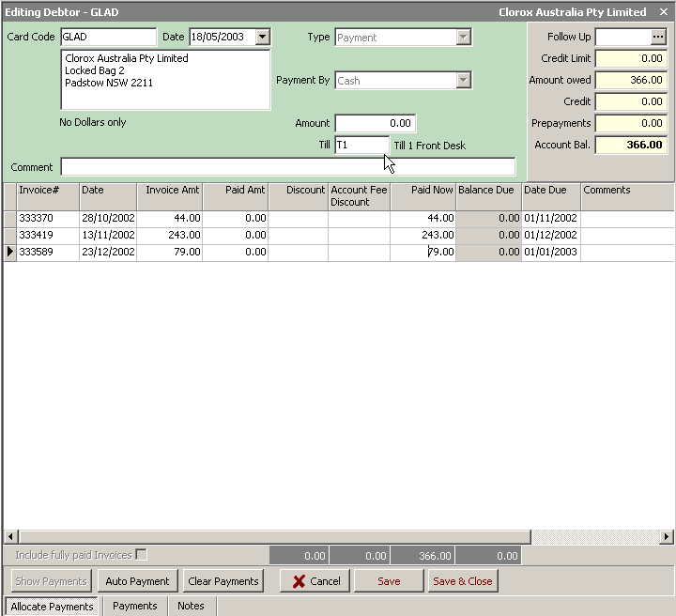

Users with the correct security rights to access Debtor records will be able to open Debtor records and record payments in the normal fashion via a Retail Workstation. Payments recorded via a Retail Workstation will show as part of Till takings. Similarly, any refunds to debtors made via a Retail Workstation will also show as negative takings of the Till.

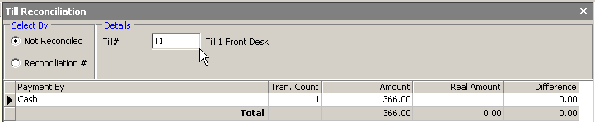

REPRINTING INVOICES

Any Invoice created at any workstation can be reprinted/faxed/emailed quickly either via the Job form itself or via the Sales register. However, retail or POS invoices are typically printed to the Docket printer and will be in a 76mm or 80mm format. If a customer requests a copy invoice done in one of your A4 layouts, simply:

- Select the Invoice either via the Sales register or Job Form.
- At the “Print Invoice” dialogue box, choose Invoice report Form SELECTED.
- Using the dropdown selection of Invoice layouts, choose an appropriate layout for the reprint.
- Select to either Print (to an A4 network printer), fax or Email.
- OK your choices.
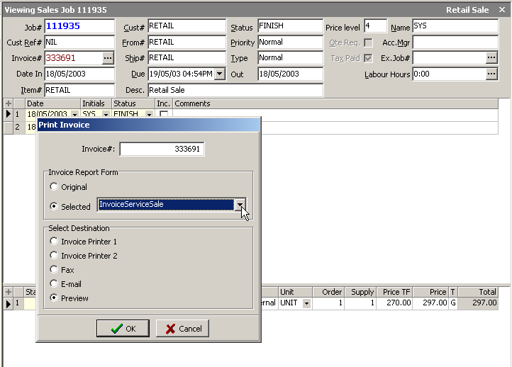

Similarly, a customer may request that a “RETAIL” POS invoice (76mm or 80mm) be re-issued with their details etc. To do this, you will need to:
- Un-print the original Invoice.
- Open the associated Sales Job and make “un-ready” to allow editing.
- Highlight the CUST#, FROM# & SHIP# and change to the customers CardCode.
- Invoice the Job again.

This will not effect any payments made applied to this invoice.

